Contents
[TC-MR12-1] Mail to MARS Groups – Windows Explorer DM Extension menu item visibility 2
[TC-MR12-2] Mail to MARS Groups – Microsoft Outlook menu item visibility 2
[TC-MR12-3] Mail to MARS Groups – Copy Group(s) Addresses from Windows Explorer DM Extension 3
[TC-MR12-4] Mail to MARS Groups – Copy Group(s) Addresses from Microsoft Outlook 6
[TC-MR12-5] Mail to MARS Groups – Select MARS Groups filter 9
[TC-MR12-6] Mail to MARS Groups – Copy Addresses of Active Users only 10
[TC-MR12-7] Mail to MARS Groups – No Group(s) selected 14
[TC-MR12-8] Mail to MARS Groups – Group with no users 16
[TC-MR12-9] Mail to MARS Groups – Group with no Active users 17
[TC-MR12-10] Mail to MARS Groups – Disabled Groups 20

[TC-MR12-1] Mail to MARS Groups – Windows Explorer DM Extension menu item visibility
Result: PASSED
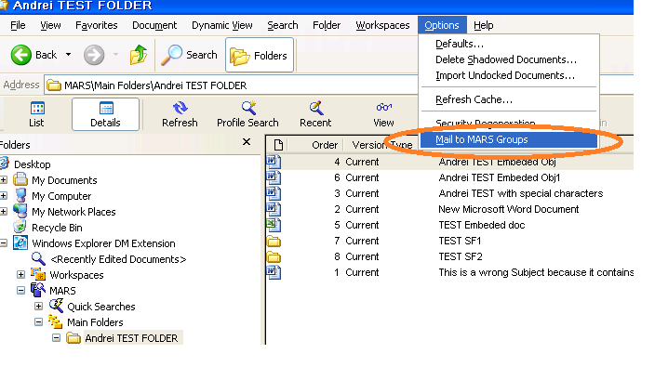

[TC-MR12-2] Mail to MARS Groups – Microsoft Outlook menu item visibility
Result: PASSED
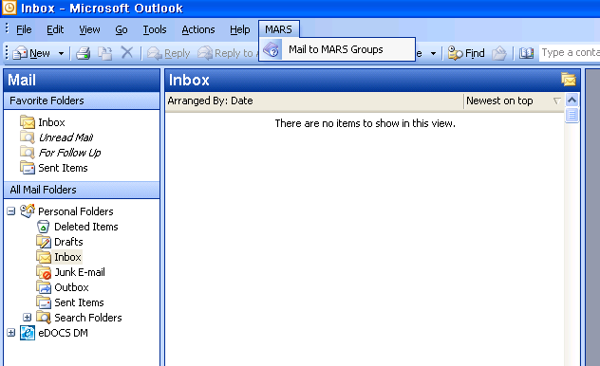

[TC-MR12-3] Mail to MARS Groups – Copy Group(s) Addresses from Windows Explorer DM Extension
Result: PASSED
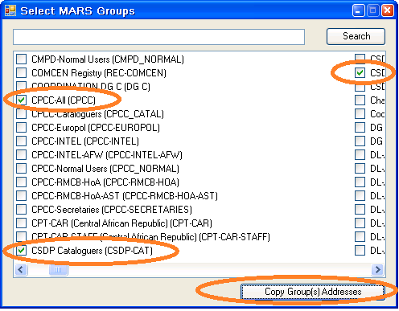
The group selected at the right:
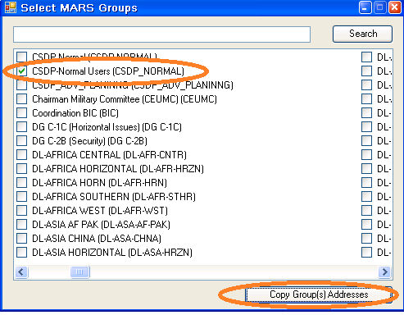

Result: Content of the clipboard-Exchange addresses of the members of the selected groups
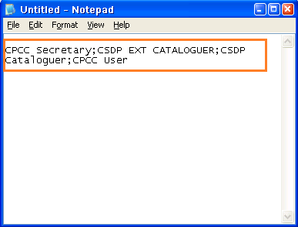

[TC-MR12-4] Mail to MARS Groups – Copy Group(s) Addresses from Microsoft Outlook
Result: PASSED
Select groups for "To…":
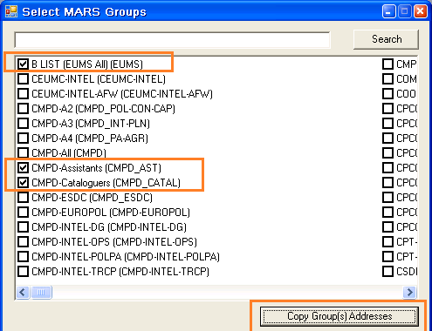
The content with the members of selected groups pasted from the Clipboard into "To…" textbox:
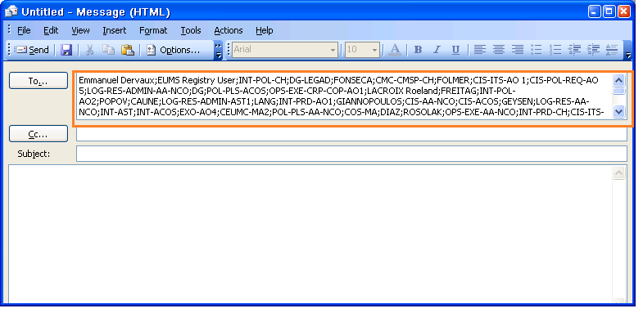
Another group which is used below and for which we have less, known members…
Select for "To..":
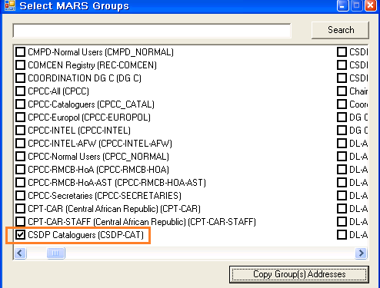
Clipboard content pasted into "To…" textbox:
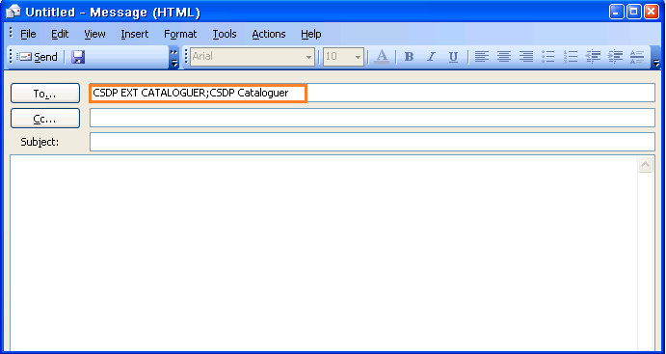

Select for "CC…"
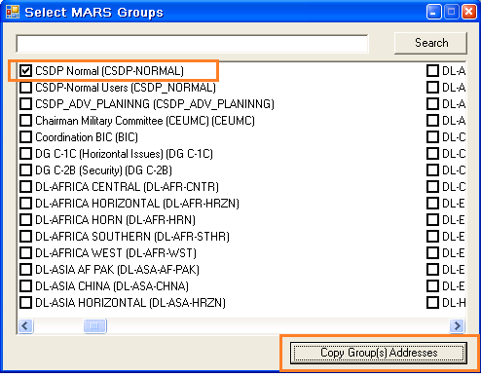
Clipboard content pasted into "CC…" textbox:
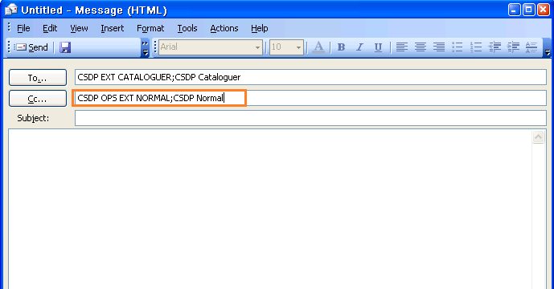

[TC-MR12-5] Mail to MARS Groups – Select MARS Groups filter
Result: PASSED
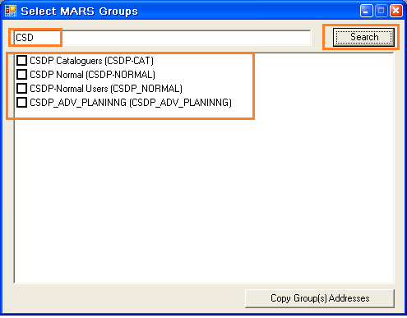

[TC-MR12-6] Mail to MARS Groups – Copy Addresses of Active Users only
Result: PASSED

Targeted groups: CPCC-All, CSDP Cataloguers, CSDP Normal Users
Preconditions:
Pick user CSDP EXT CATALOGUER to be disabled.
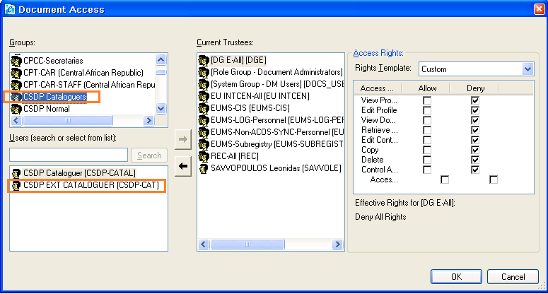
Disable chosen account from the group
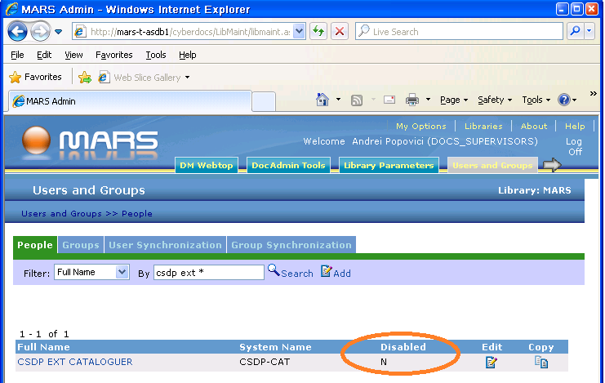
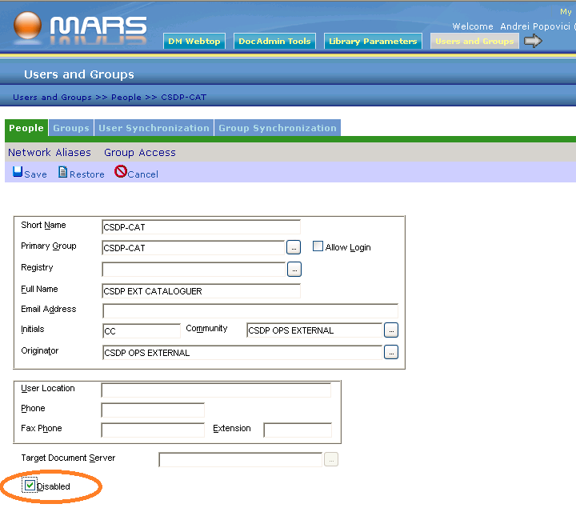
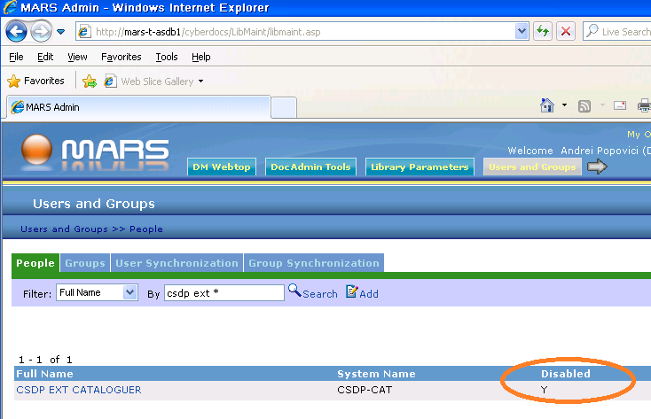

Test
Selecting groups:
The group selected at the right:

CSDP EXT CATALOGUER (which was disabled) is missing from the list of active users displayed in the Notepad file (reflecting the content of the Clipboard).
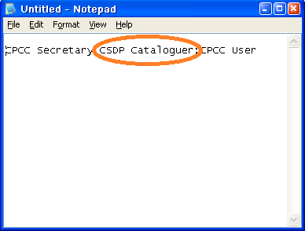

[TC-MR12-7] Mail to MARS Groups – No Group(s) selected
Result: PASSED
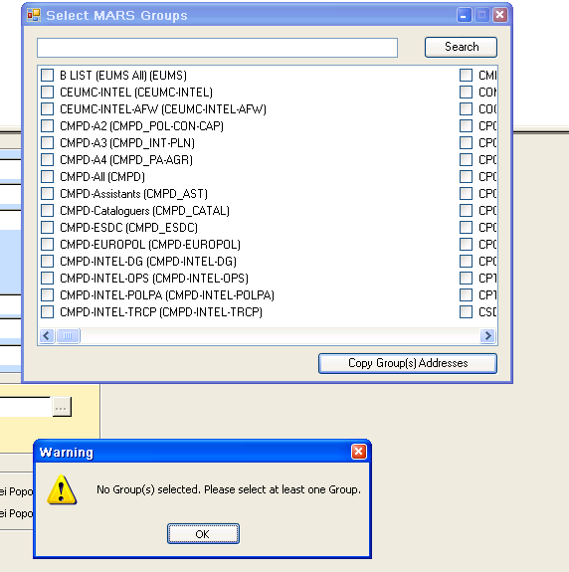

[TC-MR12-8] Mail to MARS Groups – Group with no users
Result: PASSED
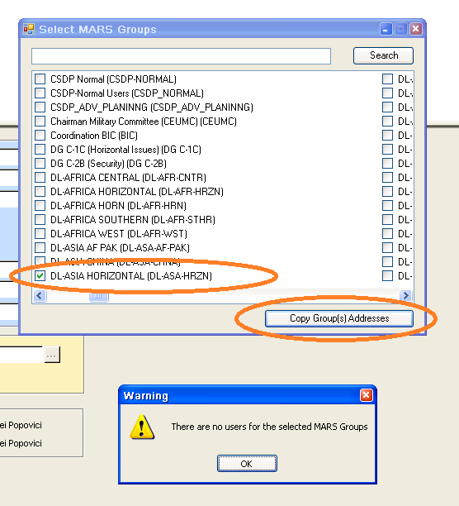

[TC-MR12-9] Mail to MARS Groups – Group with no Active users
Result: PASSED
Preconditions:
We choose the group "CSDP Cataloguers" for which we disable its members.
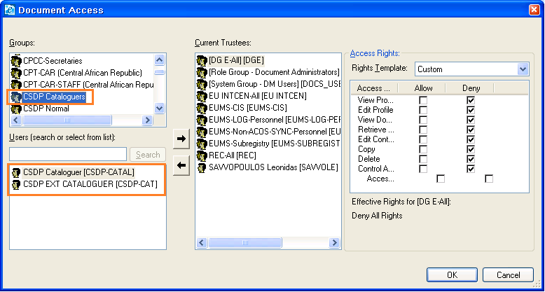

Disable members of "CSDP Cataloguers":
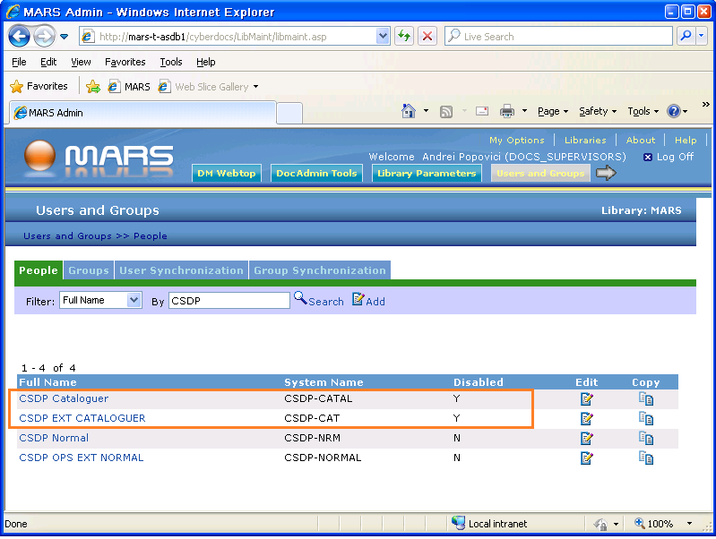

Test
Access "MARS Groups" from Outlook:
Select group with all members disabled:
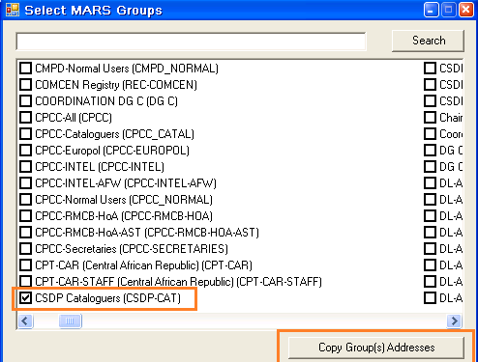
Click "Group(s) Addresses" result; Message displayed as expected.
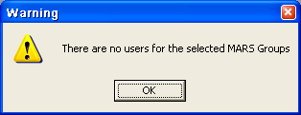

[TC-MR12-10] Mail to MARS Groups – Disabled Groups
Result: PASSED
Preconditions
Disable group "CSDP Cataloguers"
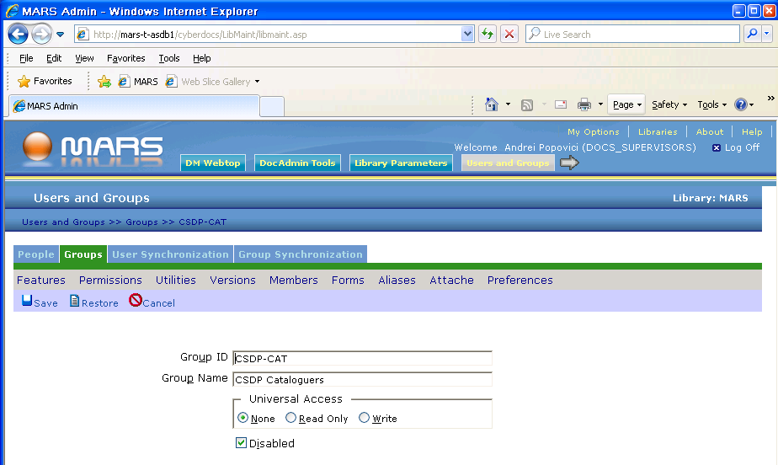

Test
Select the menu option “Mail to MARS Groups” from Outlook.
Click on “Mail to MARS Groups” to display the available groups; Result: "CSDP Cataloguers" group is missing.
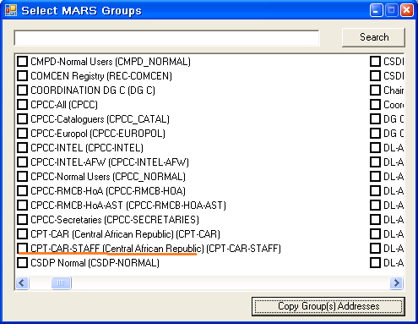

See normal position for "CSDP Cataloguers" below:

